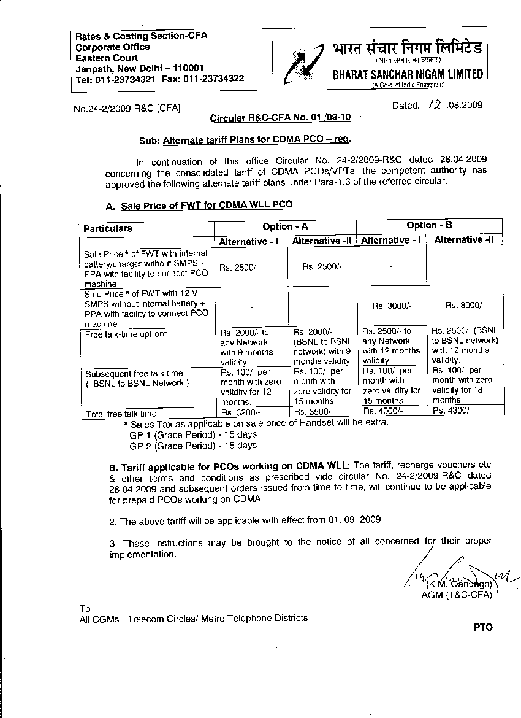

-: 2 :-
Copy to: -
- CMD, BSNL
- All Directors on BSNLs Board/ ED(Finance)
- All PGMs / GMs, BSNL,CO
- All GMs ,CMTS Zonal Billing Centers
- GM (IT) – for updation of BSNL Website
- DDG (Marketing) - for arranging adequate publicity to attract customers for PCO Business.
- Guard File.

